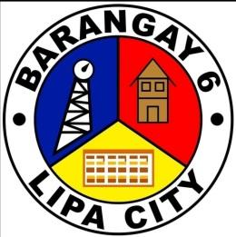

**REPUBLIC OF THE PHILIPPINES**

**CITY OF LIPA**

**BARANGAY SAIS (6)**

**(043)332-8621**